Automating Attendance Tracking with Dlib Face Recognition

Nithin Jose

*PG Scholar  
 Master of Computer Applications   
 Amal Jyothi College of Engineering*

*Kottayam,Kerala*  
[nithinjoseman@gmail.com](mailto:nithinjoseman@gmail.com)

.Gloriya Mathew

*Assistant Professor  
Master of Computer Applications   
 Amal Jyothi College of Engineering Kottayam,Kerala*  
[gloriyamathew@amaljyothi.ac.in](mailto:gloriyamathew@amaljyothi.ac.in)

Abstract: "Automating Attendance Tracking with Dlib Face Recognition" transforms conventional attendance management techniques by utilizing state-of-the-art facial recognition technology, the. Through the integration of Dlib's pre-trained neural network, our system is able to identify persons with an unprecedented level of efficiency and accuracy. By doing away with the necessity for manual documentation and verification, this creative method lowers errors and streamlines administrative procedures. Moreover, our solution effortlessly incorporates demographic information, providing personalized attendance monitoring and perceptive analysis. We enable institutions and companies to make data-driven decisions and allocate resources as efficiently as possible by utilizing deep learning algorithms. This project offers a scalable and dependable solution for a variety of sectors and educational institutions, marking a significant progress in the field of attendance management.

Keywords— Deep Learning, Face Recognition, Personalized Monitoring, Convolutional Neural Networks (CNNs), Attendance Management, Dlib, face_recognition.

# **INTRODUCTION**

Face recognition attendance systems are a significant development in contemporary workforce management. The accuracy, effectiveness, and user experience of traditional attendance tracking technologies are frequently hampered. Our initiative intends to transform this procedure by utilizing state-of-the-art technologies like machine learning and computer vision. Our novel method combines React frontend with Django backend to create a smooth interface for real-time face detection and capture. We provide an automated system to optimize attendance management by combining facial recognition and OpenCV techniques with a strong database structure. Combining cutting edge technology with years of experience in web development can greatly improve organizational effectiveness, maximize resource use, and raise overall output. We demonstrate the scalability, practicality, and dependability of our system through rigorous testing and validation, opening the door for its widespread adoption and revolutionary influence on workforce management techniques.

# **LITERATURE REVIEW**

In today’s fast paced world, traditional methos of attendance management have become outdated and prone to errors [1]. By utilizing sophisticated computer vision techniques, the "Smart Attendance System using Dlib Pre-Trained Neural Network" offers a state-of-the-art method for managing attendance. Face detection has sparked a lot of attention since it is frequently employed in vision systems for computers for autonomous control and communication [2]. The core of the system's face recognition capabilities is formed by pre-trained neural network models for facial detection and recognition provided by the popular open-source library Dlib. With the goal of improving the precision, effectiveness, and ease of attendance monitoring, this study expands on previous research in the areas of face recognition and attendance management systems. The system uses pre-trained models from Dlib to detect and recognize faces effectively in real-time, making attendance monitoring easy and manual input-free. The attendance system provides a number of benefits, including user friendliness, reduced manual work, data management, time tracking, and many more [3]. This lessens the faults and inaccuracies that come with using standard attendance systems in addition to reducing administrative overhead. Face recognition is another type of biometric recognition that maintains all of a person's facial traits as distinct face prints in order to uniquely identify them [4]. A novel technique to automatic student and people counting based on facial identification, when a video security camera is installed to count the number of people who enter a door [5]. An automated system will save time and money for the organization [6]. The main goal of this project is to create a Face Recognition-based attendance system that will turn this manual process into an automated one [7]. Deep Learning is a method or branch of machine learning that consists of algorithms composed of high-level abstractions on data that uses non-linear transformation functions that are laid out in layers and depth or it can be said as artificial intelligence that imitates the workings of the human brain’s nerves [8]. In addition, the project's adherence to contemporary web development techniques is demonstrated by the integration of Django as the backend framework and React as the frontend framework, which allow for a user-friendly interface and smooth interaction with the attendance system. All things considered, the "Smart Attendance System using Dlib Pre-Trained Neural Network" promises improved accuracy and efficiency in a range of organizational and educational contexts, marking a substantial improvement in attendance tracking.

# **MOTIVATION**

Since technology is transforming every aspect of our lives in our fast-paced world, attendance management solutions are more crucial than ever. By applying cutting-edge facial recognition technology, our objective is to improve accuracy, expedite attendance tracking methods, and raise overall productivity. Our goal is not just to make things easier, but to empower organizations to make data-driven decisions, allocate resources optimally, and foster an accountable culture. Through this seminar, we hope to encourage innovation, foster positive change, and ultimately aid in the advancement of contemporary society.

**IV . METHODOLOGY**

### Convolutional Neural Networks (CNNs), a type of deep learning technique, and pre-trained models for feature extraction and classification are used in the face recognition process. An outline of the procedure is as follows:

## **Data Collection:**

During the face attendance system's data gathering phase, you obtain a sizable dataset of employee faces straight from the business's databases. This dataset is essential for properly training the facial recognition model. Multiple photos of each employee's face are gathered and kept in designated directories within the system to guarantee robustness and correctness. These folders represent individual employees and act as repositories for the face photos. The goal is to increase the model's capacity to correctly identify different people in different scenarios by gathering a wide variety of face photos.

## **Data Preprocessing:**

The dataset is carefully preprocessed after the collection of face photos in order to get it ready for model training. Several important tasks are involved in this preprocessing step. First, the training, validation, and test sets make up the three subsets of the dataset. This department makes sure the model is appropriately assessed for performance criteria and trained on a wide variety of samples. Preprocessing methods including scaling, normalization, and grayscale conversion are also used to standardize the data and make model training more effective. Optimizing the quality of the dataset and facilitating the model's learning process are the two main objectives of data preprocessing.

## **Model Selection:**

The OpenCV and face_recognition libraries are used in conjunction with the Django framework for image processing and face recognition activities in the facial attendance system. CNNs are used internally by face_recognition for the extraction and classification of facial features. The face_recognition library uses pre-trained CNN models to extract features and classify them based on information from large-scale image datasets. The technology also employs picture data gathered from a video stream to focus on real-time face detection and recognition activities.

## **Data Augmentation:**

Enhancing the face attendance system's deep learning algorithms' performance requires the application of data augmentation approaches. These methods add variations to already-existing photos by artificially growing the training dataset, which improves the model's accuracy in identifying faces. To expose the model to a greater variety of facial appearances and orientations, geometric modifications like rotation, shearing, and zooming are frequently employed to enrich the dataset. All things considered, data augmentation is essential to improving the model's resilience and precision in identifying employee faces for attendance tracking.

## **Model Training and Evaluation:**

We have used an extensive model training and evaluation procedure when creating our attendance register program. The software is trained to recognize people from live video streams with accuracy by utilizing facial recognition algorithms. We maximize the model's capacity to discriminate between faces that we recognize and those that we don't, using techniques like decreasing binary cross-entropy loss. Furthermore, we produce ROC curves and compute AUC values to assess the program's discriminatory power and ability to generalize to new data. This meticulous methodology guarantees the dependability and efficiency of our attendance register program that is based on facial recognition. The flow chart is given in Fig 1.

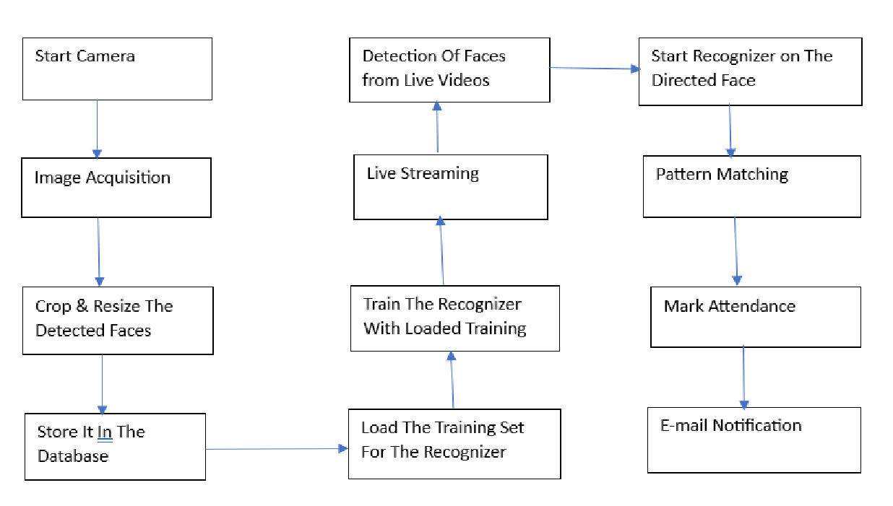

Fig 1: Flow Chart

## **Import statements :**

Attendance register using face recognition needs to use several packages. The packages imported are given in Fig 2

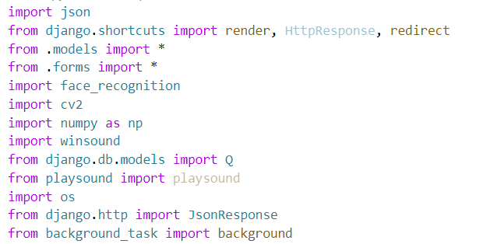

Fig 2: Import statements

## **Integration and User Interface:**

The powerful functionality and user-friendly interface of the attendance register system are achieved through the seamless integration of multiple technologies. With a front-end interface designed with React.js, the system can easily interface with a backend that was created with.NET and SQL Server. The face recognition component effectively transfers identified facial data to the React front-end, enabling users to interact with the system intuitively and receive real-time updates. As this is going on, the.NET backend controls how employee attendance information is stored and retrieved from the SQL Server database, guaranteeing the accuracy and consistency of the data.

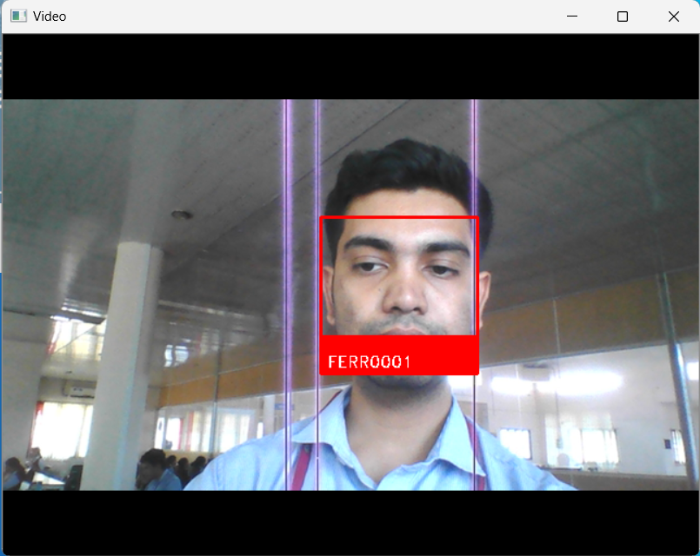

Fig 3: Face Recognised

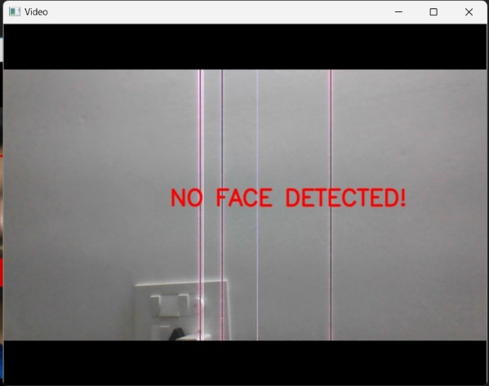

Fig 4: Face not detected

## **Model Deployment:**

The system will be installed with camera configurations carefully placed at the office building's entrance and departure points. Employees may easily record their attendance as they come and go from the office thanks to this deployment. Real-time identification of persons is made possible by the facial recognition model through the continuous recording of live video feeds by the deployed cameras. The employee's admission or exit is automatically recorded by the attendance system upon recognition, which expedites the process of recording attendance. Employees may easily register their attendance using this deployment method. Fig 5 and Fig 6 displays this user interfaces.

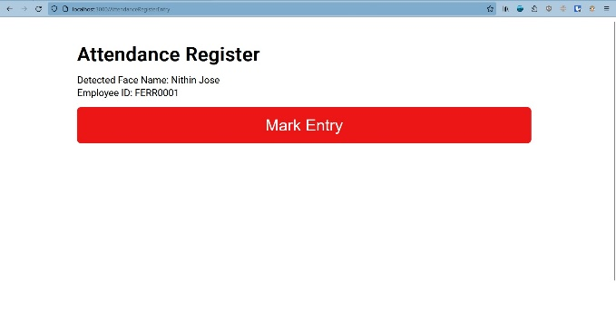

Fig 5: Register at Entry

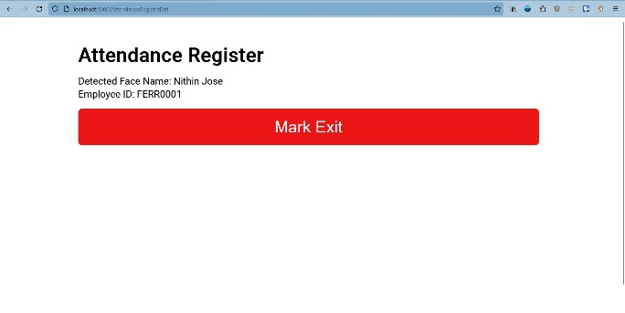

Fig 6: Register at Exit

**V. RESULT**

The face recognition attendance registers system's core functionality is based on pretrained models from dlib, specifically the face_recognition model. This decision is based on the deep learning architectures' (particularly Convolutional Neural Networks') strong image processing and classification capabilities. CNNs are essential for accurately recognizing faces because they automatically identify the spatial hierarchies of features within input data. CNNs are excellent in extracting features and analyzing them from images because they have convolutional, pooling, and fully connected layers. While pooling layers improve translation invariance and lower computing complexity by down sampling feature maps, convolutional layers use filters to identify patterns. Fully connected layers use these extracted features to carry out accurate classification tasks, such real-time facial recognition. Our solution is able to monitor attendance in an effective and dependable manner by utilizing pretrained models such as face_recognition from dlib. This helps to improve efficiency in work environments. By adding as many face photographs as they like, customers can improve accuracy because the system supports a dynamic amount of face images.

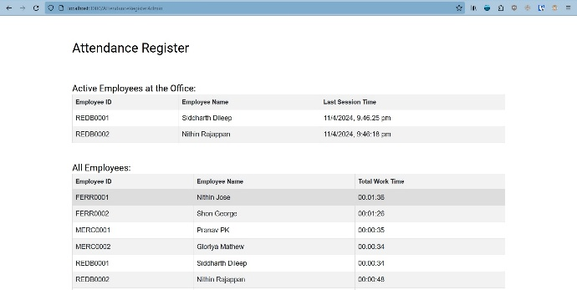

Fig 7: Attendance register admin view

**VI. CONCLUSION**

To sum up, the creation of our facial recognition attendance register is a major development in contemporary attendance control systems. We've developed a reliable and effective method for tracking attendance in a variety of contexts by fusing cutting-edge facial recognition technology—including pretrained models from dlib and the face_recognition library—with Django backend and React frontend frameworks.

The functionality of our system has been greatly aided by the effective application of computer vision algorithms for face identification and recognition. We can now reliably identify people in real time by utilizing pretrained models, which makes attendance monitoring easier and eliminates the need for manual input. Through this integration, we can guarantee that our system is convenient and accessible to users in a variety of settings, which lowers the administrative strain and boosts productivity.

We have shown the efficacy and dependability of our system in precisely identifying people and logging their attendance through extensive testing and improvement. The attainment of elevated accuracy rates in various lighting situations and facial orientations can be attributed mostly to the utilisation of pretrained models. This invention not only exemplifies how technology may revolutionize the attendance tracking industry, but it also establishes a standard for other initiatives that want to use cutting-edge technology for administrative duties. We're dedicated to keeping improving our system going forward and looking into new avenues to boost usability and efficiency, which will ultimately lead to better operational workflows and attendance management procedures.

##### **VII. References**

[1] Kishan Kushwaha et al. Proceedings of the Fourth International Conference on Smart Electronics and Communication (ICOSEC-2023), Research Title “ A CNN based Attendance Management System using Face Recognition”, [2023]

[2] Ainampudi Kumari Sirivarshitha et al. 9th International Conference on Advanced Computing and Communication Systems (ICACCS), Research Title “ An approach for Face Detection and Face Recognition using OpenCV and Face Recognition Libraries in Python” [2023]

[3] Nivedhitha DP et al. Proceedings of the 5th International Conference on Smart Systems and Inventive Technology (ICSSIT 2023). Research Title “ Smart Attendance System using Dlib Pre-Trained Neural Network” [2023]

[4] Prof. Deepali Joshi et al. International Conference on Nascent Technologies in Engineering (ICNTE 2023), Research Title “ Face Recognition Based Attendance System” [2023]

[5] Kunal Ugale et al. 2nd International Conference for Innovation in Technology (INOCON), Bangalore, India. Research Title “ Modern Face Recognition Attendance System Using Open CV” [2023]

[6] Chunduru Anilkumar et al. Second International Conference on Augmented Intelligence and Sustainable Systems (ICAISS 2023). Research Title “ Smart Attendance System with Face Recognition using OpenCV” [2023]

[7] Prof. C.D. Sawarkar et al. International Research Journal of Modernization in Engineering Technology and Science. Research Title “ ATTENDANCE SYSTEM BY FACE RECOGNITION USING DEEP LEARNING” [2024]

[8] Andre Budiman et al. 7th International Conference on Computer Science and Computational Intelligence 2022. Research Title “ Student attendance with face recognition (LBPH or CNN): Systematic literature review” [2022]